Conference & Medical Camp Registration
Accommodation at:

- Shared Accommodation in Madang Province, PNG
- Cost: 60 – 80 Kina per day (sharing)
Couple rooms price TBA
- Registration: $150

Please send the Registration form and fee of $150 by cheque/money order/electronic transfer to the address below by 15/12/11.

Or electronic transfer – Healthcare Christian Fellowship Oceania BSB: 033046 Account no: 170217 by 15/12/11.
Name_____________________________________________________________
Occupation (for Medical Camp purposes):
_________________________________
Address __________________________ _________________________________
_________________________________
Phone ___________________________
Mobile___________________________
Email ___________________________
Next of Kin Contact (for emergencies) ________________
(Relationship)_____________________

Please send cheques payable to
Healthcare Christian Fellowship Oceania Inc:
PO Box 8170, Burwood Heights,



Contact Details

In AUSTRALIA
PO Box 8170,
Burwood Heights,
Victoria 3151, Australia.

Phone:
(613) 9899 0345 (Janet)
(613) 9887 9654(Padmini)
Email: hcfioceania@yahoo.com.au
Website: www.hcfi.givengain.org

In PNG
Dr. Billy Selve
PO Box 856
MADANG 511
Papua New Guinea

Phone: 675 73656456
Email: billyselve@yahoo.com.au
Mobile: +675 4221772

Healthcare Christian
Fellowship PNG

“Come, follow me and I will make you fishers of men.” Matt. 4:19

HCF PNG Outreach- Madang
February 17th-23rd 2012

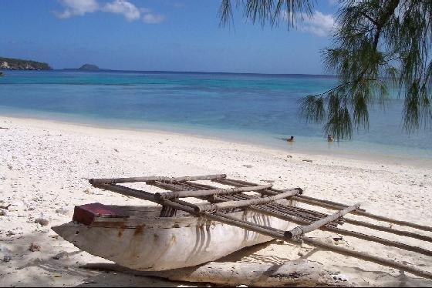

National Conference

Programme for Conference:
- Bible Exposition
- Intercession for Healthcare Fields
- Times of Worship
- Devotional Messages

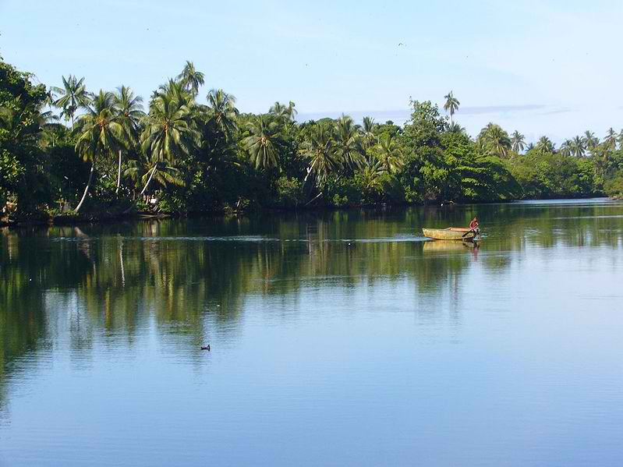

Conference Venue

The Conference will be held from Friday17th February 2012 to 19th February 2012 in Madang Province, PNG.

All delegates will be expected to handle their payments with the Guesthouse directly. The payments can only be made in Kina. Please ensure exchange of money is made at the airport, upon arrival into the country. Credit cards are not commonly accepted.

All delegates need to make certain that they have a passport that is valid for at least 6months and obtain a PNG visa. Info found at:
http://www.visalink.com.au/

Frequently Asked Questions Relating to obtaining visa found at
http://www.em.com.pg

Travel Insurance is strongly recommended.

Immunizations and vaccinations that are recommended can be found on http://www.travelclinic.com.au/ or by visiting your family doctor.

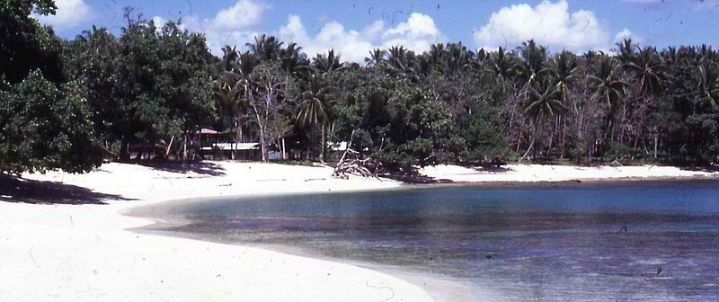

Speakers for the Conference

Livingstone Tavul
Madang, PNG
National Co-coordinator PNG
Dr. Billy Selve
Madang, PNG.
Chairman of HCF PNG.

Dr. Chelliah Gnanaharan
Melbourne, Australia
Regional Promoter, HCFI Oceania

Transport

Transport in Madang will be arranged by the local HCF. From the Airport to the accommodation will be the individual’s responsibility (most likely taxi).

Medical Camp

The Medical Camp will be held from Monday, 20th February to Thursday, 23rd February 2012 at Rural Clinics, Madang.

We will work directly with the locals in the village on a daily basis.

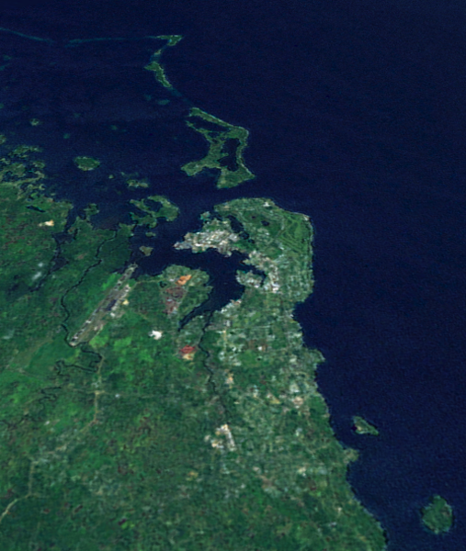

Madang

“Halili Joe, a diabetic patient we saw at our first Medical Camp, is doing much better now that he has been correctly diagnosed. He is now on insulin BD and the glucometer has made it possible for him to stay with his family here in the village.

It is still a challenge for us all as there is no refrigeration here on the island. So far so good, but the challenge will be when the hotter months come. He is gaining weight and is able to do some light work around the house now. Thank you so much for giving him a better quality of life and supporting the people here.” Sue Batcock.

